**Experiment - 9**

**Topology:**

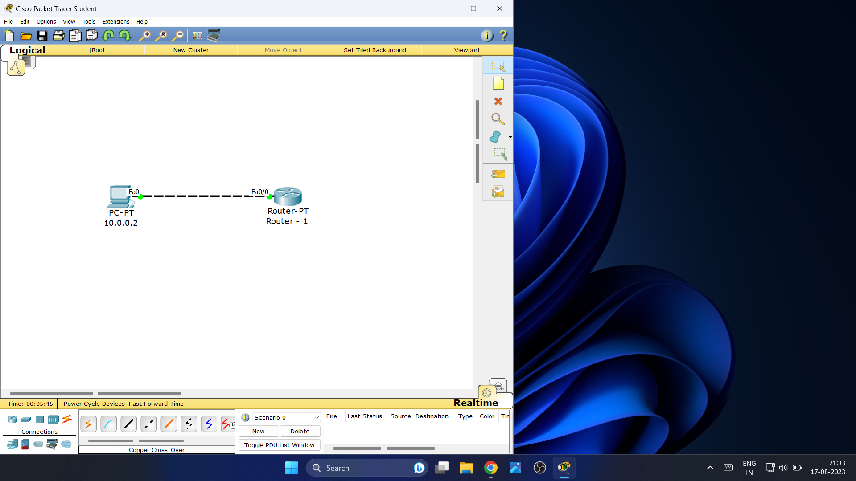

**PC - 1 Configuration:**

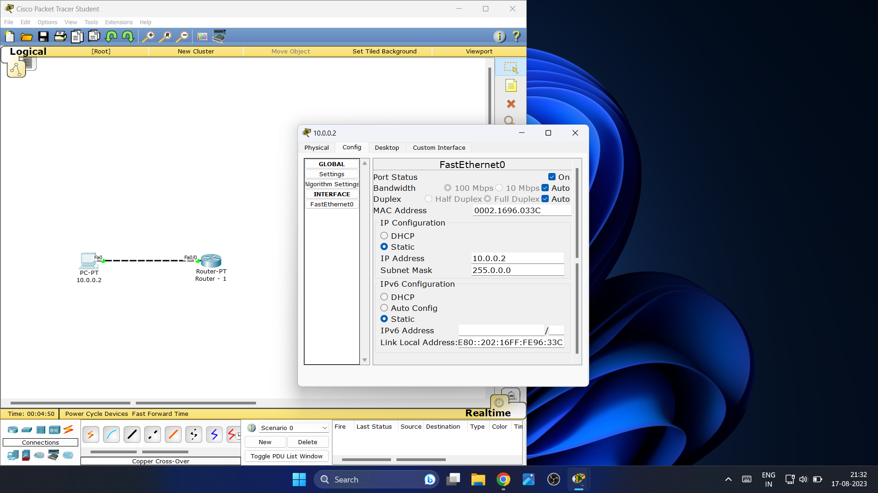

**Router - 1 Configuration:**

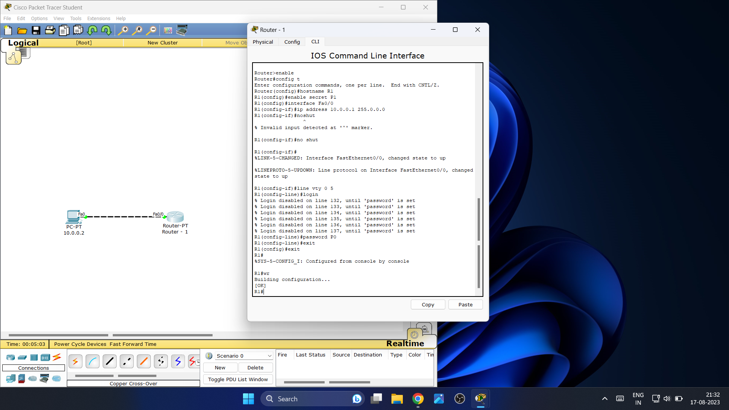

**PC - 1 (Command Prompt):**

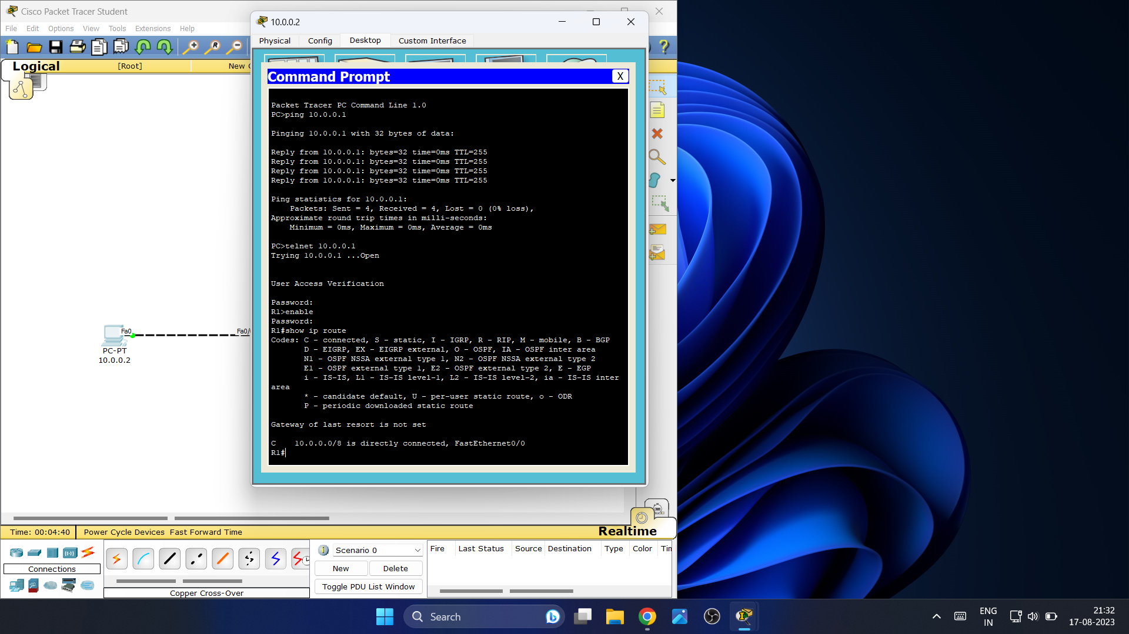

Password for User Access Verification is: **P0**

Password for enable is: **P1**